Game-Theory-Based Balance: Formalizing the Machine Unlearning Problem as a Game Between Model Provider and Data Provider

PhD Proposal Submitted to

By
Mr. Abhishek Hupele
Reg. No.: 240900465
Computer Scientist (PE), Research and Development - EV
EdgeVerve Systems Limited, An Infosys Company

Under the Supervision of
Dr. Sanjay Singh
Professor (Guide)

Dr. P.C. Siddalingaswamy
Associate Dean (Co-Guide)

Dr. Naveen Kulkarni (Co-Guide)
Director – Product Engineering - AI
EdgeVerve Systems Limited, An Infosys Company

Introduction
With the tremendous technological advancement in Artificial Learning (AI) and Machine Learning (ML) in the last decade, it’s adoption has increased many fold and has infiltrated our life as an integral part of majority of digital services we interact with [1].
Now, if AI and ML are engines driving the technology revolution, Data is its fuel. Popular phrase “Garbage In and Garbage Out”, Accurate and Reliable Data is more so important in this era, which makes this technology meaningful.
Personally Identifiable Information (PII) is a treasure trove, highly relevant and not easily available, which has lead to violations of privacy and personal data is used without consent, which in turn has led people more exposed and vulnerable. Several cases like Cambridge Analytica (2018), Apple Card Gender Bias (2019), Amazon Hiring Algorithm (2018), Clearview AI Facial Recognition (2020), Target Pregnancy Prediction (2012), Cross-Border GenAI Misuse (Predicted by Gartner, 2025) have come into light which violated the PII norms and deviate from Responsible AI principles.
This has led governments worldwide to pass legislations for an individuals “Right to be Forgotten”, there by necessitating large corporations compliance. Notable laws are the GDPR in the European Union [1][2][16], the PIPEDA privacy legislation in Canada [1][2][17], the California Consumer Privacy Act in the United States [1][2][18] and Digital Personal Data Protection Act, 2023 in India [19].
This originated interest and research in Machine Unlearning as prominent discipline. Suppose your data has been used for training, say for example by an Ecommerce company to train their recommendation engine, or your medical history is used by big Pharma industry, or your financial data is used by Credit Card, Insurance, Ecommerce companies, or your geo-location, gender, Facebook, Instagram, email data is used for political election targeting and manipulation. This opens up whole bag of worms for an individual exposing his/her financial, health , and other personal data which can be used to harm the person of interest.
Now, suppose your data has been used with or without your knowledge, or you have unknowingly given consent and at later stage you want to take back your consent, the person should have choice to share data or not, and also option to choose to what extent the data can be used and control over what data is being used. Now, withdrawing consent would trigger deletion of data, but it is not simple as that , suppose your data is being used to train ML models, Deep Learning (DL) models or LLM models , the data can be called truly removed only if the data is removed from such models or its contribution is removed. This whole problem of removing PII data from models falls under Machine Unlearning.
Now, it poses multiple challenges:
First, it is two edge sword , if all or majority of people in the world choose to refrain from allowing any type of their data to be used, than we as a society and individual will not be able to reap benefits of all the technological advancement that can be possible. For example, your medical data can be used to train for disease prediction like cancer or ecommerce recommendation engine helps you to locate desired product from millions of choices by showing relevant results, or may be as a recruiter you get help from AI to shortlist relevant candidates from thousands of applications, these are only few of the examples.
Basically, technology should be used for making your life easier, save your time, do things efficiently which needs data to stay relevant in many cases, so as I said its two edge sword, lack of data will make AI models irrelevant in certain critical scenarios and on the other hand exposing data may harm individually financially , mentally.
So there needs to be balance, and safe guards for data privacy, and choice to the individuals giving control over how and what data of theirs is used.
Secondly, removing the data already used to train complex models like DL, ML and LLMs, is highly difficult for reasons like randomness, catastrophe effect, complex algorithm. And it is not always easy to find the contribution of particular data point.
Third, Guarantee of Removal, if some model provider claims that particular data has been removed, the verification of that claim is also a challenge called certified removal [8][20].
Fourth, there are so many algorithms , scenarios, models in the play and there is no generalized machine unlearning algorithm that fits for all. There are data providers , model providers than there are malicious players which use Membership Inference Attacks (MIA), Jailbreak etc. To give different scenarios like for example: Federated settings there are multiple agents, Feature Based Unlearning, Outcome could be bias.
Fifth, removing data leads to decline in model performance, also the difference in output of old and new unlearned model can be used to obtain information on data [1][2][21].

Literature Review
[1] Machine Unlearning: A Survey HENG XU, TIANQING ZHU, and LEFENG ZHANG, University of Technology Sydney, Australia WANLEI ZHOU, City University of Macau, China PHILIP S. YU, University of Illinois at Chicago, United States
[2] Machine Unlearning: A Comprehensive Survey WEIQI WANG, University of Technology Sydney, Australia ZHIYI TIAN, University of Technology Sydney, Australia CHENHAN ZHANG, University of Technology Sydney, Australia SHUI YU, University of Technology Sydney, Australia
[3] Stefanos Leonardos and Georgios Piliouras. 2022. Exploration-exploitation in multi-agent learning: Catastrophe theory meets game theory. Artif. Intell. 304 (2022), 103653. DOI: http://dx.doi.org/10.1016/j.artint.2021.103653
[4] Lei Cui, Youyang Qu, Mohammad Reza Nosouhi, Shui Yu, Jianwei Niu, and Gang Xie. 2019. Improving data utility through game theory in personalized differential privacy. J. Comput. Sci. Technol. 34, 2 (2019), 272–286. DOI:http: //dx.doi.org/10.1007/s11390-019-1910-3
[5] Xueqin Liang, Zheng Yan, Robert H. Deng, and Qinghua Zheng. 2021. Investigating the adoption of hybrid encrypted cloud data deduplication with game theory. IEEE Trans. Parallel Distrib. Syst. 32, 3 (2021), 587–600. DOI:http://dx.doi. org/10.1109/TPDS.2020.3028685
[6] Jiahui Geng, Qing Li, Herbert Woisetschlaeger, Zongxiong Chen, Fengyu Cai, Yuxia Wang, Preslav Nakov, Hans-Arno Jacobsen, Fakhri Karray A Comprehensive Survey of Machine Unlearning Techniques for Large Language Models DOI: https://doi.org/10.48550/arXiv.2503.01854
[7] Exploring Federated Unlearning: Review, Comparison, and Insights Yang Zhao, Member, IEEE, Jiaxi Yang, Student Member, IEEE, Yiling Tao, Student Member, IEEE, Lixu Wang, Student Member, IEEE, Xiaoxiao Li, Member, IEEE, Dusit Niyato, Fellow, IEEE, and H. Vincent Poor, Life Fellow, IEEE
[8] Chuan Guo, Tom Goldstein, Awni Y. Hannun, and Laurens van der Maaten. 2020. Certified data removal from machine learning models. In 37th International Conference on Machine Learning (Proceedings of Machine Learning Research, Vol. 119). PMLR, 3832–3842. Retrieved from http://proceedings.mlr.press/v119/guo20c.html.
[9] Reinforcement Unlearning Dayong Ye∗ , Tianqing Zhu† , Congcong Zhu† , Derui Wang‡ , Kun Gao∗ , Zewei Shi‡ , Sheng Shen, Wanlei Zhou† , and Minhui Xue‡ ∗University of Technology Sydney, †City University of Macau, ‡CSIRO’s Data61, Torrens University Australia, https://arxiv.org/pdf/2312.15910
[10] Xiaofeng Ding, Hongbiao Fang, Zhilin Zhang, Kim-Kwang Raymond Choo, and Hai Jin. 2022. Privacy-preserving feature extraction via adversarial training. IEEE Trans. Knowl. Data Eng. 34, 4 (2022), 1967–1979. DOI:http://dx.doi. org/10.1109/TKDE.2020.2997604
[11] Bo Zhang, Hancheng Ye, Gang Yu, Bin Wang, Yike Wu, Jiayuan Fan, and Tao Chen. 2022. Sample-centric feature generation for semi-supervised few-shot learning. IEEE Trans. Image Process. 31 (2022), 2309–2320. DOI:http://dx. doi.org/10.1109/TIP.2022.3154938
[12] Jiajing Zhu, Yongguo Liu, Chuanbiao Wen, and Xindong Wu. 2022. DGDFS: Dependence Guided Discriminative Feature Selection for predicting adverse drug-drug interaction. IEEE Trans. Knowl. Data Eng. 34, 1 (2022), 271–285. DOI:http://dx.doi.org/10.1109/TKDE.2020.2978055
[13] [Wu et al., 2023] Xinwei Wu, Junzhuo Li, Minghui Xu, Weilong Dong, Shuangzhi Wu, Chao Bian, and Deyi Xiong. DEPN: Detecting and editing privacy neurons in pretrained language models. In Houda Bouamor, Juan Pino, and Kalika Bali, editors, Proceedings of the 2023 Conference on Empirical Methods in Natural Language Processing, pages 2875–2886, Singapore, December 2023. Association for Computational Linguistics.
[14] [Jia et al., 2024] Jinghan Jia, Jiancheng Liu, Yihua Zhang, Parikshit Ram, Nathalie Baracaldo, and Sijia Liu. WAGLE: Strategic weight attribution for effective and modular unlearning in large language models. In The Thirty-eighth Annual Conf
[15] A Survey on Recommendation Unlearning: Fundamentals, Taxonomy, Evaluation, and Open Questions Yuyuan Li, Xiaohua Feng, Chaochao Chen*, Senior Member, IEEE, and Qiang Yang, Fellow, IEEE
[16] Alessandro Mantelero. The EU proposal for a general data protection regulation and the roots of the ’right to be forgotten’. Comput. Law Secur. Rev., 29(3):229–235, 2013.
[17] O. of the Privacy Commissioner of Canada. Announcement: Privacy commissioner seeks federal court determination on key issue for canadians’ online reputation.
[18] Lydia de la Torre. A guide to the california consumer privacy act of 2018. Available at SSRN 3275571, 2018.
[19] Digital Personal Data Protection Act, 2023. Available at https://www.meity.gov.in/static/uploads/2024/06/2bf1f0e9f04e6fb4f8fef35e82c42aa5.pdf
[20] L. Bourtoule, V. Chandrasekaran, C. A. Choquette-Choo, H. Jia, A. Travers, B. Zhang, D. Lie, and N. Papernot, “Machine unlearning,” in Proc. IEEE Symposium on Security and Privacy (SP), 2021
[21] Hengzhu Liu, Tianqing Zhu, Lefeng Zhang, Ping Xiong, “Game-Theoretic Machine Unlearning: Mitigating Extra Privacy Leakage”, in JOURNAL OF LATEX CLASS FILES, VOL. 14, NO. 8, AUGUST 2021 1

Research Gaps identified
Many open areas of research exist in this field, like theoretical framework, feature based unlearning, unlearning in foundational models (LLMs), federated unlearning, incentive mechanism , sequential unlearning, game theory based unlearning, verification of unlearning , unlearning in reinforcement, dynamic unlearning for streaming data, human-in-the-loop unlearning.
Game-theory-based balance [1] : game theory is a booming field with several privacy preserving technique’s being developed in last decade, can machine unlearning be treated as a game between model provider and data provider ? where we can define set of strategies and utility by which we can achieve a trade-off or equilibrium where model performance is acceptable and also it balances responsible ai concerns around security, fairness, transparency and privacy.
Incentive Mechanism: study strategies on how to deigning a system which incentivizes users to share data as well as preventing misuse of their data and keeping performance good need to be studied. In federated settings which can have multiple users , users should be able to ask for data removal partial or fully without loss in model performance.
Foundational models are complex with billions of parameters, it is difficult to find contributions of data points with certainty, although some work has been done in this area, we would like to explore a game theoretic framework between unlearning performance and privacy modules similar to done in deep learning and multilayer perceptron models [21].
Now, in Machine Unlearning there could be many different attributes like models, dataset, utility, game theory framework’s, harmful agents, various unlearning settings (federated, sequential , dynamic etc.) below diagram shows landscape of potential game theory opportunities to be explored.
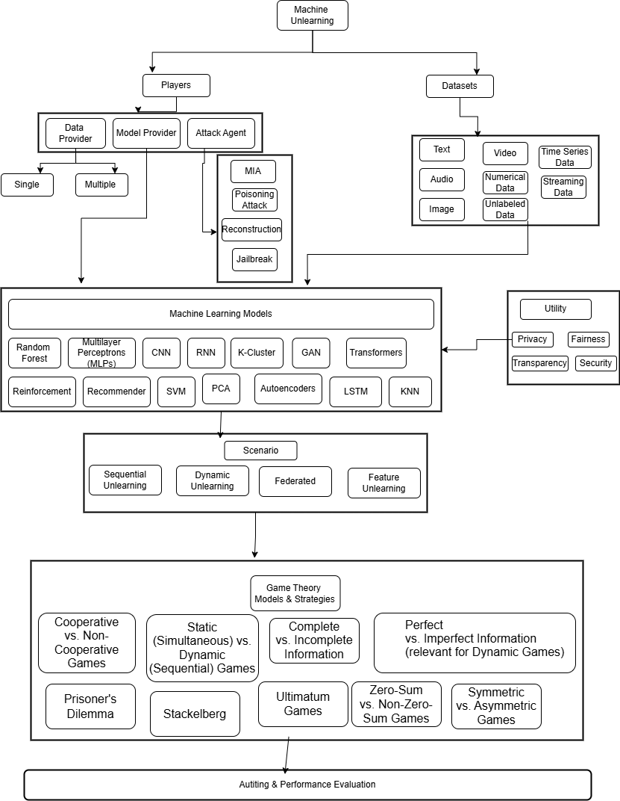

Objectives

Our objective is to reach optimum state of model in efficient way across multiple possibilities, and develop guideline framework for different scenarios and achieve desired equilibrium state or best possible outcome based on constraints.
The task is to develop strategies including multiple agents and based on different models, scenarios or desired outcomes , design game models to achieve balance with usable outcome efficiently, now each task will have multiple options to choose, data provider wants to minimize data sharing, while model provider wants to maximize data collection ideally, but lets work toward a strategy to achieve a balance, there may be some data which is very relevant for the task and some data which may be PII and is not contributing much and so we need a strategy to arrive at those relevant attributes which are needed , also suggest some benchmark on the data and model performance tradeoff – how to arrive at such benchmarks, also using existing verification methods to audit unlearning in our procedure.
Now, as in diagram in Section 3, we see there could be a lot of variations and attributes into play, which makes the study very broad in terms of ground to be covered in limited time, what we propose is identifying most promising areas of research and will begin with those promising areas like feature engineering, extending existing study on game theory[21], llm unlearning or any other topic which is seen or emerges fit. We would also attempt to consolidate similar strategies and methodology wherever possible.
We attempt to develop a generalized game-theory-based framework which will guide on the strategies that can be applied based on the attributes as in diagram in Section 3. But before developing a unified game-theory based framework we will need to do individual studies on specific focus areas which can lead to foundation for generalization.
Proposing Objectives :
- “Game-Theoretic Machine Unlearning : Beyond Membership Inference
Or
“Game-Theoretic Machine Unlearning: Balancing Utility and Fairness"
Or
“Game-Theoretic Machine Unlearning: Foundational Paper”

In pilot study worked on the paper by Liu et all [21] which focusses on MIA (privacy) , intend to extend it to one or few of the areas (not all) : exploring broader attack models, integrating with differential privacy, scalability to foundational models, adaptive strategies, cross-domain (test on diverse datasets to evaluate), fairness balance.
This paper is proposed to focus on Deep Neural Networks or other Machine Learning models with parameters in millions or less.
- "Feature-Aware Game-Theoretic Machine Unlearning: Enhancing Privacy Protection in SISA Models"
In pilot study implemented SISA from scratch, we would like to extend it game-theoretic based unlearning model, implement feature based strategies to reach equilibrium stage.
- “Game-Theoretic Machine Unlearning: Foundational Models”
Unlearning as game on LLMs , using same principles in Liu et al. [21] and research in our 1st objective, apply them to LLMs
- "Dynamic Extensions of Game-Theoretic Machine Unlearning for Evolving Data Ecosystems"
This paper will extend on previous research to include one or few of the areas as follows: federated unlearning, dynamic unlearning for streaming data, human-in-the-loop, model specific (like reinforcement, random forest etc.) ; and integrate it in game theory framework ; I have refrained from giving specific area here as I feel previous research topics and knowledge gained will steer it in right direction , hope to cover ground for unified game theory paper.
- “Game-Theoretic Machine Unlearning: Unified Framework”

Detailed Methodology
The research will delve into developing theoretical model followed by simulation experiments.
Literature review is at core of any research, a deep dive into game theory and existing research in machine unlearning.
Game model selection and development, intend to study game theory models and evaluate the applicability based on these characteristics, apply them to machine unlearning problem, by creating theoretical framework.
Theoretical framework will involve identifying the players involved, the strategy options available to players, clearly defining different utility functions, designing & defining the game settings, identifying which game model will be suitable, and equilibrium analysis. Further analyzing equilibrium and its implications to the desired outcome/utility.
Doing simulation experimentation for the designed theoretical framework, based on observations identify the best strategy and make recommendation on strategies , explain relationship between the strategy, attributes and utility.

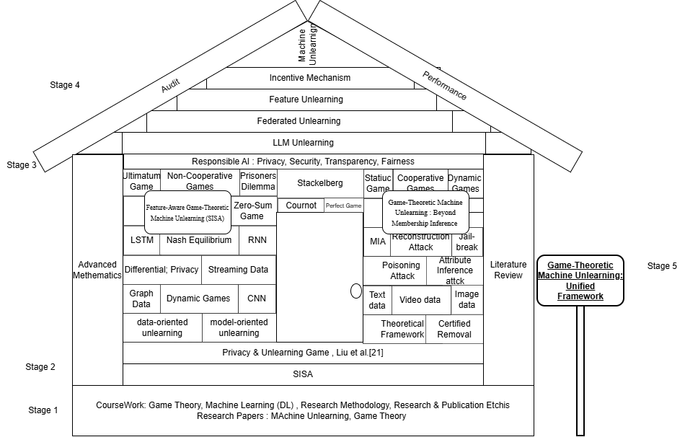

Stage 1 :
While Literature review is on-going activity and will overlap with on going research, in this we will focus on acquiring initial knowledge on base topics of :
- Game Theory (Theory + Application)
Includes course work and basic application of game theory principles to machine unlearning using coding (MLPro-GT or other frameworks, Python)
- Machine Unlearing: Literature Review
- Advanced Mathematics, Equilibrium Analysis
- Machine Learning : Deep Neural Networks, LLMs
Stage 2:
Focus on 1st and 2nd Objectives:
- Implement SISA model from scratch – this model is applied to Deep Neural Networks and it’s core idea is very simple and easy to comprehend which makes it suitable for beginning stages
  - Deliberate on game theory strategies applicable
  - Feature based strategy
  - Dynamic strategy for streaming data
  - Delve into theoretical framework and distributed data aspects, Equilibrium Analysis
  - Design feature based game theoretical framework for implementation
    - Implement feature based strategy
    - Implement any other game theory strategies if applicable
- Implement privacy (MIA) vs unlearning paper [21] from scratch, further
  - Understand how responsible ai pillars – fairness (optional security, transparency, can be picked up later) plays role in machine unlearning, how it is ensured, how loss function changes and deliberate on its usage in machine unlearning
  - How MIA vs unlearning implementation will differ in different settings like federated, dynamic, feature based
  - Loss function calculations and mathematical proof in Liu et al., Equilibrium Analysis
  - Understand broader attack models like attribute inference, reconstruction, poisoning attacks
  - In stage 1, we studied on game theory , further explore dynamic game formulations attacker and defender strategies can evolve
  - Application to other datasets like graph, video, audio , extent of coverage text and image datasets
  - Application of Liu et al. [21] to other machine unlearning models like reinforcement, random forest, KNN, etc.
  - basic know-how for LLMs as we will cover it in detail later.
  - Implement code in python, tensorflow, pytorch
Stage 3:
By this stage hope to have improved understanding of advanced mathematical concepts, focus on data contribution , SHAPLY values and on theoretical frameworks.
Focusing on LLMs. Federated , and other models and scenarios at this stage, extending our research to objectives 3 and 4, guided by research till now
Stage 4:
Game Theory Model and Development
Expanding the game theory framework to include broader areas as in Section 3 diagram.
Focus on theoretical frameworks.
Focus on Auditing and verifiable frameworks in game theory.
Stage 5 :
Working on Unified Framework, scope will cover research till now and may include few more relevant and closely aligned topics.
Benchmarking and focusing on benefits of game-theory framework for faster convergence for the said requirements which could be model type, data type, utility function, real world settings etc. Ensuring efficient and effective system for machine unlearning using game theory.

Expected outcome
A formalized game model, Identify formalized game models strategies, scenario’s, agents applicability , benefits of potentially a multi-stage Stackelberg or static Bayesian game (or other strategies) , describing the strategic interactions and optimization between a model provider and a data provider in machine unlearning. This will help model providers in decision making to achieve compliance in faster and effective way.
Understand the dynamics that exist in Machine Unlearning between different players like data provider (single or multiple as in federated setting), model provider, how their strategies will change based on the task objective (fairness, privacy, transparency, security) on different settings like dynamic unlearning, sequential unlearning, catastrophic unlearning, federated unlearning, reinforcement unlearning. Develop framework that suggests the most effective and efficient way to achieving equilibrium among players in the game , the strategy to be followed and how to implement it.
Derived equilibrium strategies that illustrate optimal trade-offs between model accuracy and privacy protection, considering varying unlearning costs and privacy sensitivities.
Quantifiable results showing the effectiveness of the game-theoretic approach in reducing privacy leakage (e.g., lower membership inference attack success rates after unlearning) while maintaining competitive model accuracy.
Empowering Data Providers: Data providers (users) will be empowered with a better understanding of the dynamics involved in unlearning, enabling them to make more informed decisions about their data and privacy requests, and to assess the effectiveness of unlearning services.

Importance of proposed research investigation and mention the link to relevant SDG
Proposed research is in one of the leading topics in AI & M L industry – Responsible AI, contributing to building resilient systems, promoting inclusive & responsibility in latest innovations in Generative AI systems SDG 9.
The entire Responsible AI – Machine Unlearning concept stands on the pillars of Privacy-preserving AI at its core, ensuring lesser conflicts & chaos and justice & legal recourse to individuals right to privacy SDG 16.
This research fosters partnership between industry and academia experts by providing a platform for them to contributing equally based on there diverse experience in Responsible AI policies and implementations SDG 17.
Aim to create relevant and relevant learning outcome not only for the researcher but the research outcome will also provide lifelong learning to other students and a useful resource for other researchers working in the same domain SDG 4.
For making AI driven systems accountable we are working on implementation of “right to be forgotten” in efficient and effective way essential for designing sustainable AI systems in production SDG 12.

Research Time plan
Research Activity (TEMPLATE-to be edited as per the requirement) |  | Time ( from Registration) in Months
 |  | 06 | 12 | 18 | 24 | 30 | 36 | 42 | 48 | 54
Course Work
Literature Survey
Methodology Step 1
Methodology Step 2
Methodology Step 3
Methodology Step 4
DAC presentation and registration renewal
Conference presentations |  |  |  |  | C |  | C
Journal Publications |  |  |  |  |  | J |  | J
Preparation of Final Thesis
Synopsis presentation
Submission of Thesis
Part-time candidates - 4 years 6 months (54 months)

Pilot study / Preliminary work done
The pilot study was undertaken to understand the feasibility of Machine Unlearning with Game Theory frameworks. Since, the implementation of both are very few and not readily available. We tried to focus our pilot study in understanding existing machine unlearning and how it has potential for strategic interactions. Also, for better understanding of game theory for implementation purposes we studied code implementation. We are also tried to gain information on the datasets and experimental setups done, also we tried to analyze how game theory framework can be applied to machine unlearning by understanding and implementing existing papers.

Papers Implemented :
S. No. | Title of Paper | Authors / Year | Key Methodology Implemented | Tools / Frameworks Used | Key Findings / Observations | Relevance to Proposed Research
1 | Membership Inference via Backdooring (MIB) | Hu et al., 2022 | Membership inference using backdoor triggers and hypothesis testing | Python, PyTorch; CIFAR-10, Purchase-100, Location-30 datasets | Demonstrated that marking only 0.1% of data enables effective membership inference with statistical guarantees; ASR thresholds validated | Provides a detection mechanism for unauthorized data usage, an essential precursor to unlearning
2 | Machine Unlearning (SISA Training) | Bourtoule et al., 2020 | Sharded, Isolated, Sliced, Aggregated training for efficient unlearning | Python, TensorFlow; Purchase dataset, SVHN, ImageNet | Achieved 4.63× speed-up in unlearning compared to retraining from scratch, with minimal accuracy degradation | Establishes a scalable baseline for unlearning, which can be extended with game-theoretic strategies
3 | MLPro-GT-game theory and dynamic games modeling in Python | Steve Yuwono ∗, Detlef Arend, Andreas Schwung | Modular, Object-oriented classes for game theory implementation (players, strategies, payoffs, training etc.) | Python, MLPro | Supports dynamic game modelling, with inbuild support for strategies (Prisoner’s Dilemma, Rock-Paper-Scissors, Supply & Demand, Routing with Congestion). | Understand game theory implementation , opportunity to use and expand on existing framework.
4 | Game-Theoretic Machine Unlearning: Mitigating  Extra Privacy Leakage | Hengzhu Liu, Tianqing Zhu, Lefeng Zhang, Ping Xiong∗ | Stackelberg competition between unlearning performance and privacy protection ,loss function (model distance + classification error) | Models: MLP, CNN  Datasets: text dataset Adult, Image datasets MNIST,CIFAR10(DenseNet,ResNet) | Trade-off between utility and privacy to ensure effective machine unlearning and maintain excellent model performance | The paper directly validates the application of game theoretic framework, which will be used as building block for our research
The SISA model is very useful technique which helps to understand the basic principles of machine unlearning, it’s basic idea is very simple, but it also help us understand the overall challenges possible, we were able to implement it while we observed some code fixes were necessary. I see potential of game theory based strategic interactions in SISA , I propose to explore and implement feature based game theory framework interactions and also analyze which game theory frameworks could be applicable.
Other paper is based on MIA, understanding the factors leading to successful MIA and possible mitigation methods can actually help the players in choosing the right strategy in the game. I would like to deep dive on designing strategy game to reduce chances of successful MIA in existing Machine Unlearning algorithms including SISA and others.
For real world application going beyond theory , will need to implement our theoretical models and derive conclusion – MLPro-GT helps us by giving a reference to use or build on it, though it’s existing use case has been limited to basic cases and not complex, it can be stepping stone to implement our logic and expand on its existing implementation.
For “ Game-Theoretic Machine Unlearning: Mitigating Extra Privacy Leakage” diagramshows the scope and
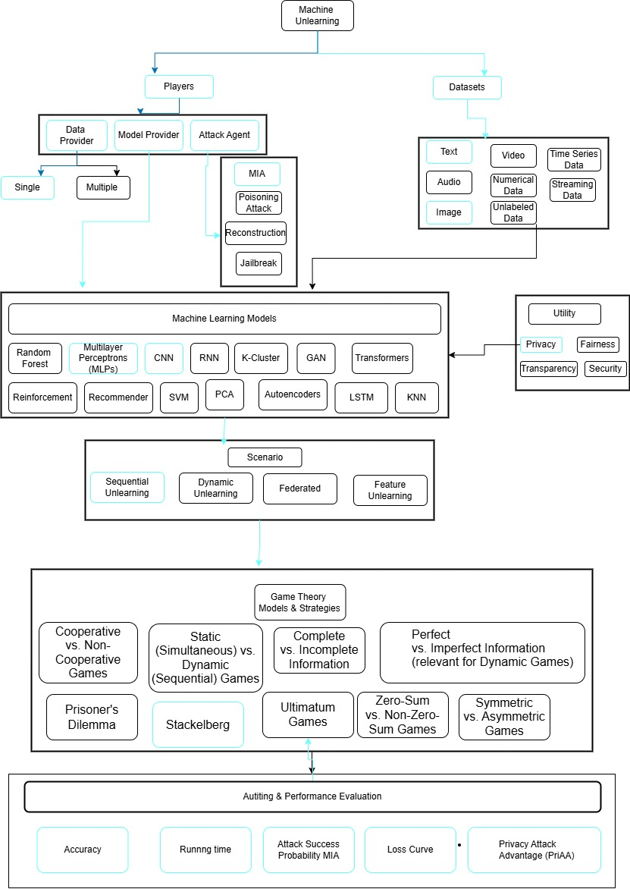

🔹 Conclusion
The pilot study confirms the feasibility of integrating Game Theory into Machine Unlearning.
  - Current unlearning methods focus on efficiency but ignore strategic interactions (e.g., balancing user privacy demands vs. provider resource costs).
  - Game Theory can formalize these negotiations, ensuring fairness and incentive compatibility.

Details of expenses and source of funding (detailed break-up of research related expenses for consumables/software/equipment/travel etc. to be given along with details of source of funding. If the study does not require funding, same to be mentioned with justification. Scholarships/fellowships awarded to the candidate should NOT be mentioned under research related expenses mentioned above.
Not Applicable

References:
Vancouver

Course work details suggested by DAC with credits
Serial No. | Course (description) name | Credits
1. | Research Methodology | 4
2. | RPE (Research & Publication Ethic) | 2
3. | Responsible AI | 2
4. | Game Theory | 2
5. | Machine Learning | 2

Similarity check report having total word count, index < 15% and exclude Matches<3 duly signed by the candidate and guide.
